**ECEN 325 - Lab Report**

**Lab Number: 8**

**Lab Title: BJT Amplifier Configurations**

**Section Number: 503**

**Student’s Name:** [Alex Allahar](mailto:alex.allahar@tamu.edu)

**Student’s UIN: 928009686**

**Date: 11/05/23**

**TA: Mike Ng**

1. **Measurement Plots**

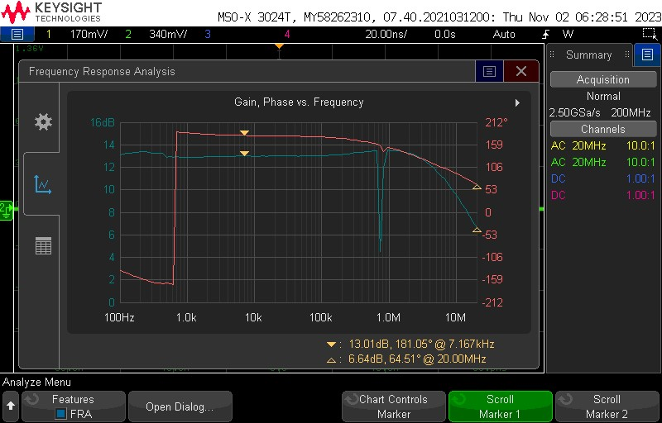

1. **Common Emitter NPN Gain Bode Plot**

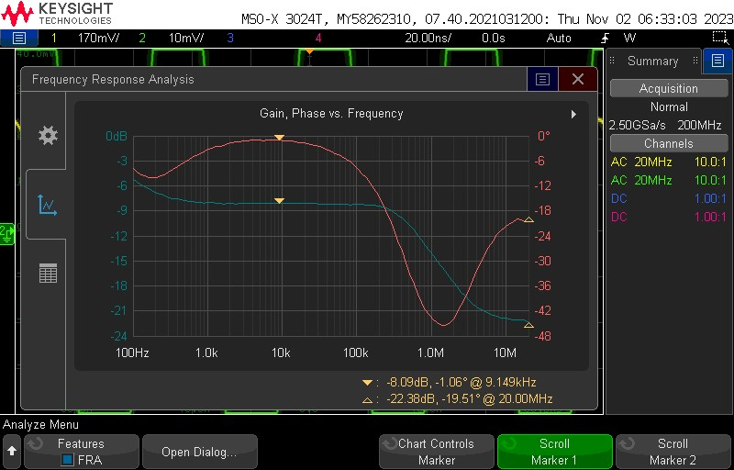

1. **Common Emitter NPN Rin Bode Plot**

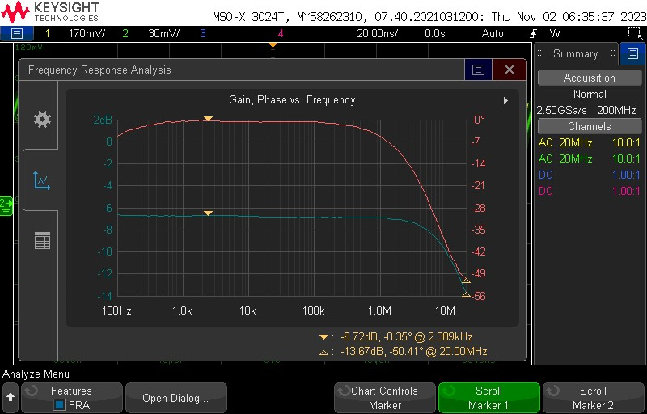

1. **Common Emitter NPN Rout Bode Plot**

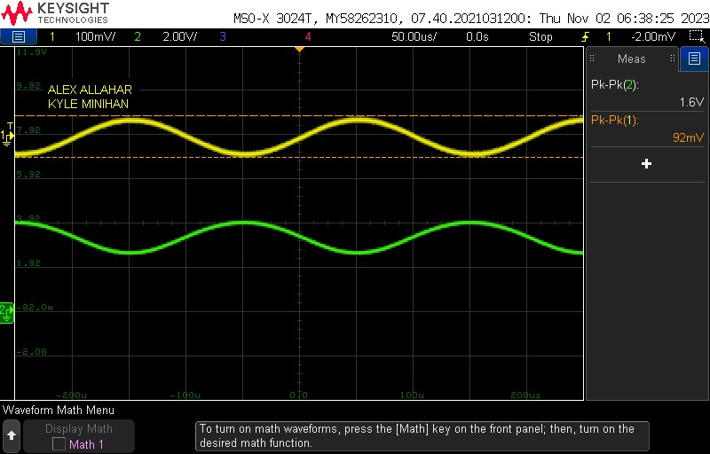

1. **Common Emitter NPN Transient Plot**

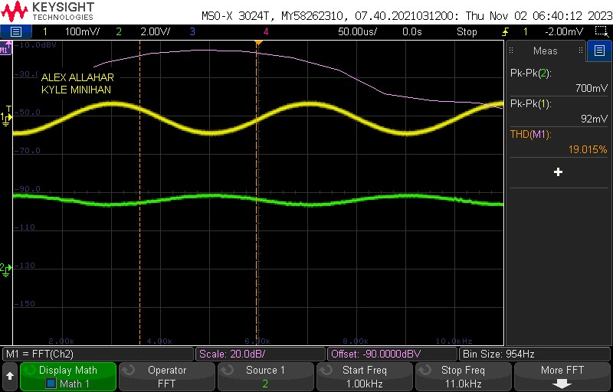

1. **Common Emitter NPN THD Plot**

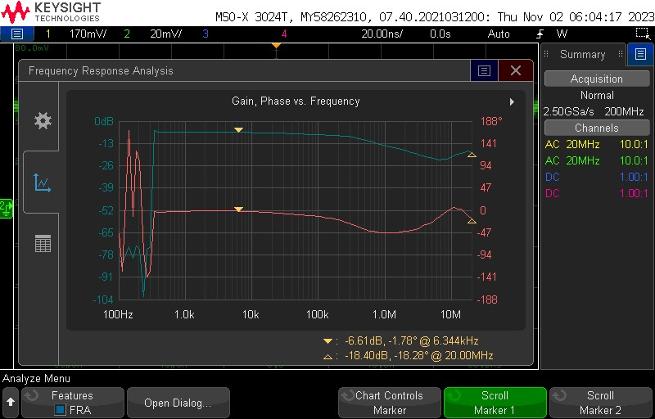

1. **Common Emitter PNP Rin Bode Plot**

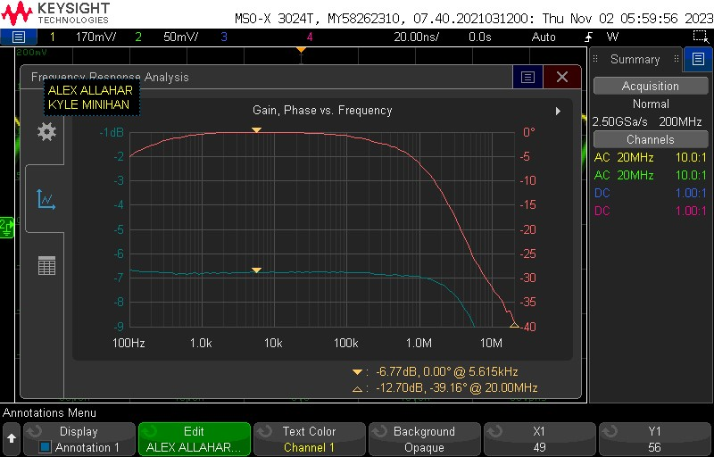

1. **Common Emitter PNP Rout Bode Plot**

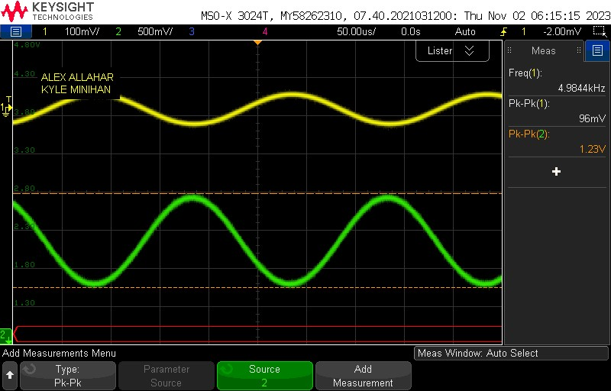

1. **Common Emitter PNP Transient Plot**

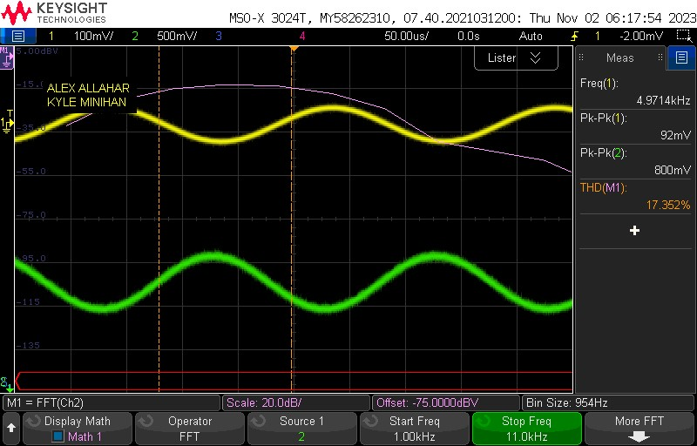

1. **Common Emitter PNP THD Plot**

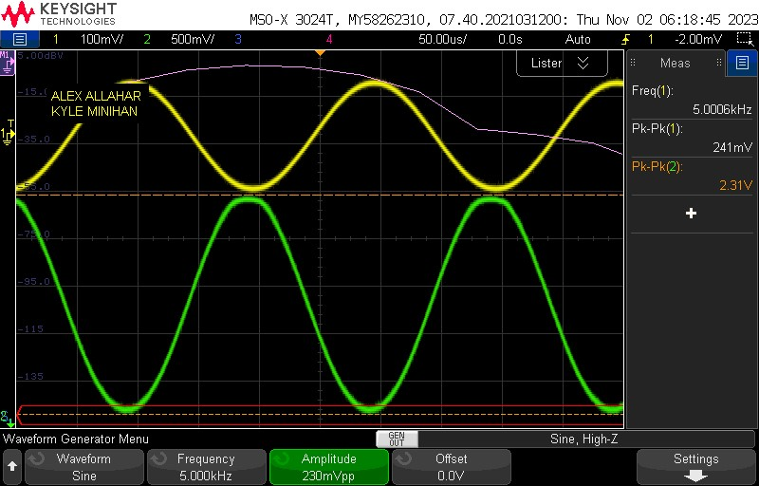

1. **Common Emitter PNP Clipping Plot**

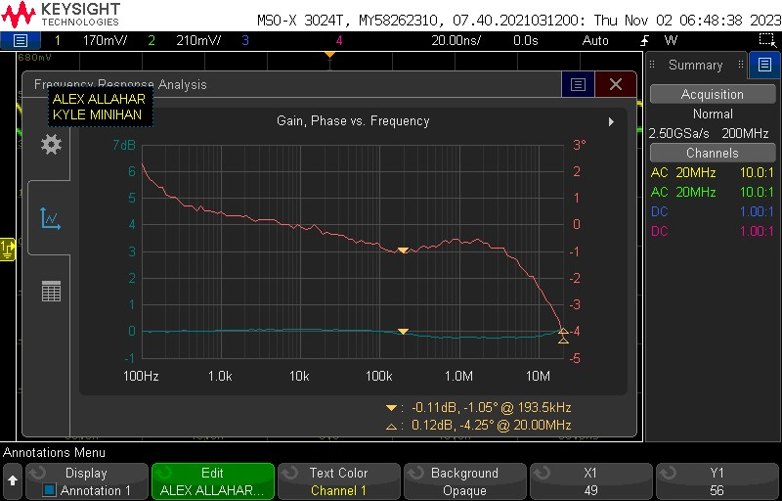

1. **Common Collector NPN Gain Bode Plot**

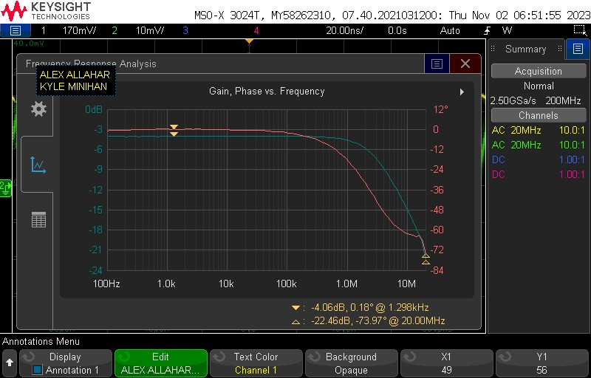

1. **Common Collector NPN Gain Rin Plot**

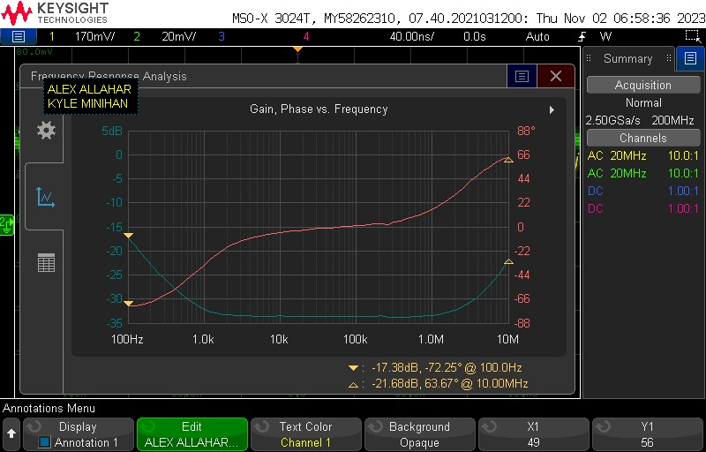

1. **Common Collector NPN Gain Rout Plot**

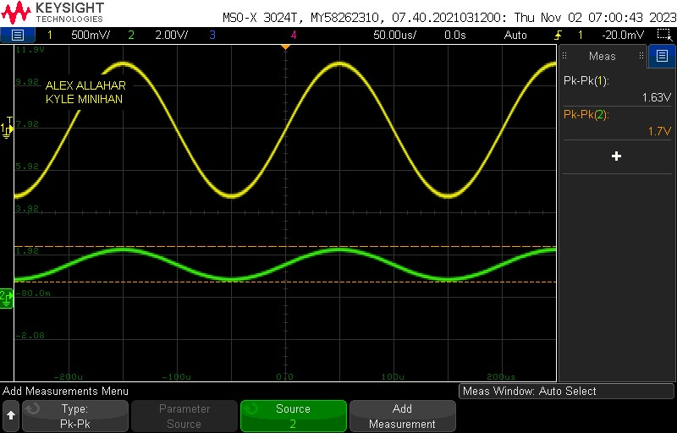

1. **Common Collector NPN Transient Plot**

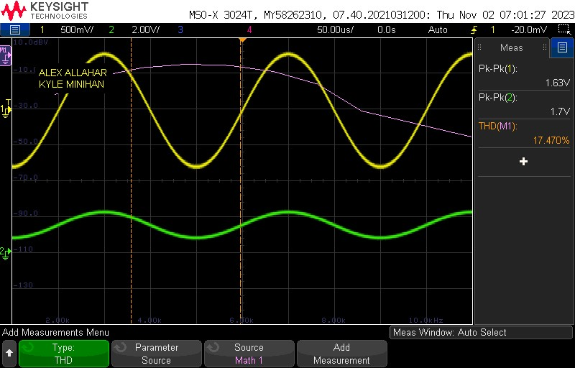

1. **Common Collector NPN THD Plot**

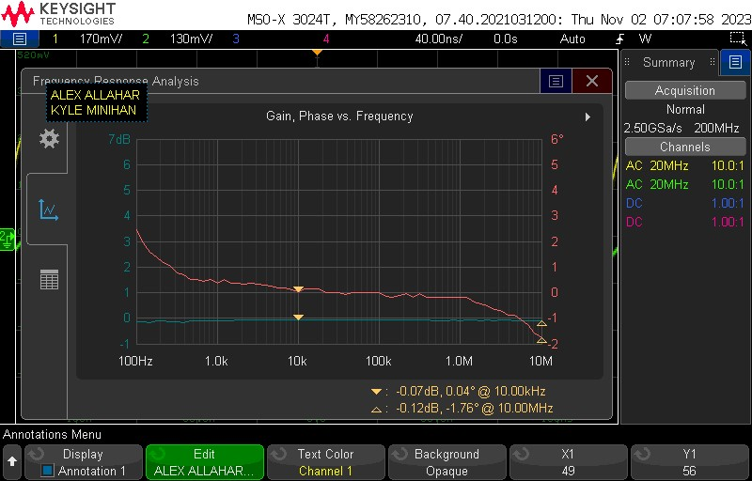

1. **Common Collector PNP Gain Bode Plot**

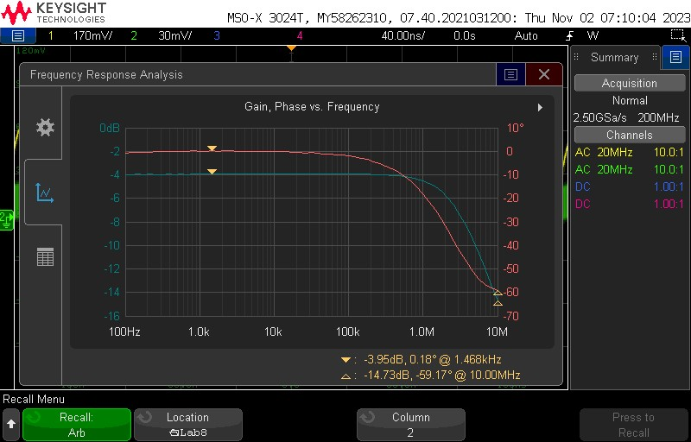

1. **Common Collector PNP Gain Rin Plot**

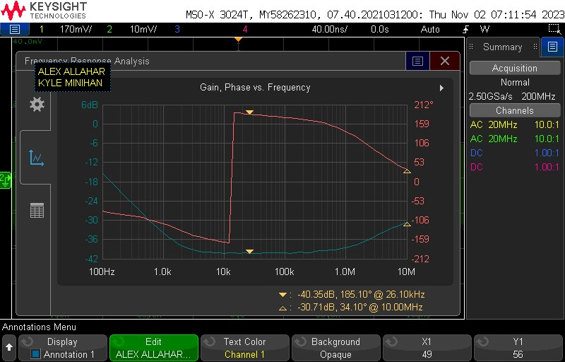

1. **Common Collector PNP Gain Rout Plot**

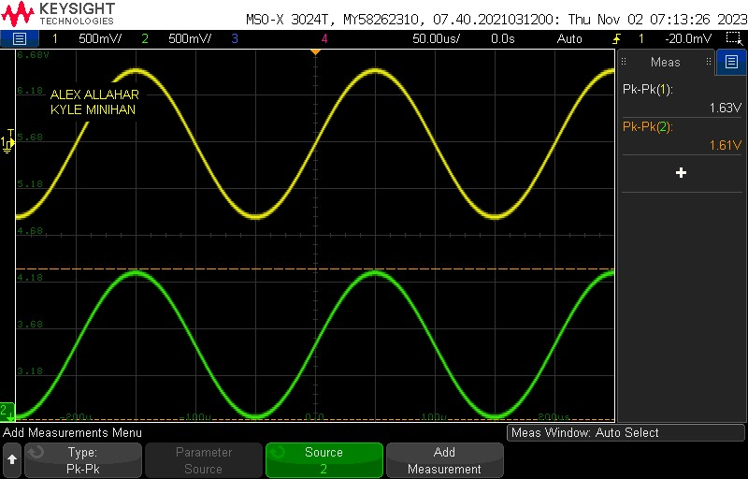

1. **Common Collector PNP Transient Plot**



1. **Common Collector PNP THD Plot**
2. **Tables**

| Value | Measurement |
| --- | --- |
| Vrb2 | 2.12 V |
| Vre | 1.48 V |
| Vrc | 2.204 V |
| Vo, dc | 2.796 V |
| Ic | 1.469 mA |
| Av | 20.00 V/V |
| Rin | 2.471 Ω |
| Rout | 1284.5 Ω |

* 1. **Common Emitter NPN Measurement**

| Value | Measurement |
| --- | --- |
| Vrb2 | 2.866 V |
| Vre | 3.514 V |
| Vrc | 1.468 V |
| Vo, dc | 2.202 V |
| Ic | 1.468 mA |
| Av | 19.32 V/V |
| Rin | 3.288 Ω |
| Rout | 1270.95 Ω |

* 1. **Common Emitter PNP Measurement**

| Value | Measurement |
| --- | --- |
| Vrb2 | 2.130 V |
| Vre | 1.483 V |
| Ic | 1.483 mA |
| Av | 0.987 V/V |
| Rin | 6360 Ω |
| Rout | 29.05 Ω |

* 1. **Common Collector NPN Measurement**

| Value | Measurement |
| --- | --- |
| Vrb2 | 2.863 V |
| Vre | 1.495 V |
| Ic | 1.495 mA |
| Av | 0.990 V/V |
| Rin | 6.599 Ω |
| Rout | 14.48 Ω |

* 1. **Common Collector PNP Measurement**

1. **Compare the results and comment on the differences**

Instead of designing the Common Base NPN Circuit, we designed the PNP Common Collector. Furthermore, the circuits worked as intended and abided by the design parameters provided in the lab manual. The Rtest was not changed for all circuits when finding Rout and Rin for the circuits; however, it did not have much effect on the THD as all circuits were around the same THD of 17 %. Thus the distortion was almost identical for each amplifier circuit.